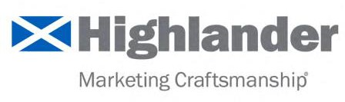

B2B Marketing Visibility & Demand Self-Diagnostic | YES | NO
1. Can we clearly explain our value proposition -- in a single sentence – so that a buyer can repeat it accurately?
2. Do we have a defined ideal client profile (industry, size, triggers, decision-makers, etc.)?
3. Do we consistently communicate directly with clients, prospects, and referral sources (not social media content)?
4. Do we own and actively use a clean and current database of clients, prospects, and referral sources?
5. Does our public-facing content reflect a clear point of view tied to what we want to be known for?
6. Do we showcase proof of expertise through case examples, outcomes, or third-party validation?
7. Do we earn visibility in credible third-party channels (media, speaking, bylines, partnerships)?
8. Would a buyer researching our category encounter our firm before a formal sales conversation?
9. Do we have a clearly defined discipline to convert market interest into identifiable engagement (download, inquiry, conversation)?
10. Do we track leading indicators of demand, not just activity, and connect them to business outcomes?

SCORING (Total Number of “Yes” Responses)
0–3 | At Risk
Your firm’s expertise is likely unclear or insufficiently visible to influence buyer consideration.
4–7 | Significant Opportunity
You have real strengths, but gaps in visibility or consistency are limiting demand.
8–10 | Well Positioned
Your marketing is reinforcing credibility, authority, and sustained buyer interest.

